Name: _________________________________________________________________
Date: _________________________

Field Lesson:
A Trip to the French Quarter

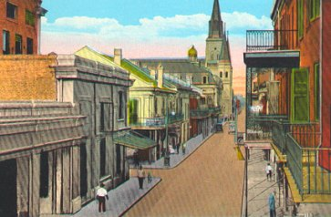

Wonderment

Directions:

1. Generate a list of questions – both thick and thin – that you want to make sure you ask during the tour

2. Questions can be about anything – Mississippi, Bienville, Micaela Pontalba, relationship with Native Americans, music, food, architecture, location of the city, French selling Louisiana, Spanish influence, Africans, slavery and Free People of Color, stuff that you haven’t learned yet in class. SHOW OFF!

How Much Do You Want to Know?

Surprise, Surprise!
Scavenger Hunt

Directions:

1. You might hear about the following people and places during the Tour. Review the list - it is always good to have a head start on the material.

2. Check out the following terms to who these people and places are.

3. Try and figure out as many of the following terms as possible while on the tour!

4. The following are places, people, events and architectural features

Terms | Significance/Summary
Jackson Square or
Plaza de Armas

Washington Artillery
Battery
French Market
Cabildo
St. Louis Cathedral
Presbytere
Pontalba Apartments
Mississippi River Levee
The Beautiful Crescent
Café D’Monde
Congo Square
Louis XIV
Iberville
Bienville
Alejandro “Bloody” O’ Reilley
Bernardo de Galvez
Andres Almonester y Rojas
Baroness Micaela Pontalba
Andrew Jackson
Jean Lafitte
Renato Beluche
Dominique Youx
Mayor Nicholas Girod
Napoleon Bonaparte
Pere Antoine
Henriette De Lille
Benjamin Butler
The 4 “F’s”
Fires of 1788 and 1794
Spanish Fire Code
River, Lake and Imported
Bricks
Wrought and Cast Iron
Balconies and Galleries
Tie Rods
Creole Cottage
Shotgun Cottage
Creole and American Townhouse
Porte Cochere
Jackson Statue
French Market Yesteryear
Mural
Jazz
Mules and Buggies
Native Americans
Cajuns
Creoles
Africans
Slavery
Free People of Color
Germans
Spanish
Americans
Irish
Italians

Extra, Extra!

- Any extra notes or thoughts can be written here – NICE WORK!

